ST.MARIE EUGENIE GIRLS SECONDARY SCHOOL

HOLIDAY PACKAGES.

**CHEMISTRY 1 FORM FOUR 2020**

INSTRUCTIONS

1.This paper consists of sections A,B & C.

2.Answer**all** questions in sections A & B,and only **one(1)** question in section C.

3.Cellular phones are **not** allowed in the examination room.

4.Non-programmable calculators are allowed in the examination room.

5Write your examination number on every page of your answer booklet(s).

6.The following constants may be used;

Atomic masses:

H=1,O=16,C=12,Na=23,Mg=24,Cl=35.5,K=39,N=14,Ca=40,Fe=56,S=32,Cu=63.5,Pb=207.

Avogadro's Number=6.02x1023.

G.M.V at s.t.p = 22.4dm3.

1Faraday =96,500 Coulombs.

Standard pressure=1atm(760mmHg).

Standard temperature=273K(0°C).

1Litre=1dm3=1000cm3.

**SECTION A(15 Marks**).

Answer **all** questions in this section.

1. For each of the items (i)-(x),choose the correct answer amongs the given alternatives and write its letter beside the item number in the answer booklet provided.

(i) A chemical substance when it is added to the carbonate or bicarbonate compound,its mixture causes effervescences.

A. NaOH solution B. AgNO3solution C. HCl solution D.AgCl solution E.CUSO4 solution

(ii) The oxidation state of nitrogen in ammonium is

A.3 B.5 C.2 D.4 E.18

(iii) Alcohols react with Carboxylic acid to form a group of compounds called

A.Aldehydes B.Ethers C. Esters D.Alkynes E.Ketones

(iv) A substance M has percentage composition of 54.6% carbon,9.1% hydrogen and the rest is oxygen.What its empirical formula?

A.C2H6O B.CH2OC.CH4D.C2H40 E.C2H8

(v) The compound C2H6 is burnt in air with bright smoky flame,what is the product formed?

A.Carbondioxide gas and oxygen gasB.Water and oxygen C.Water and carbonmonoxide gas

D.Carbondioxide gas and waterE.Oxygen gas and carbonmonoxide gas

(vi) An aqueous solution with a PH 6 is called

A.Slightlyacid B.Strongly alkaline C.Strongly acid D.Slightly alkaline E.Strongly neutral

(vii) Which method could be used to separate the product in the below equation?

Pb(NO3)2(aq) + 2KI(aq) PbI2(s) + 2KNO(aq)

ColourlessColourless Yellow Colourless

A.ChromatographyC.CrystallizationC.DistillationD.SublimationE.Filtration

(viii) Technicians prefer to use a blue flames in welding because

A.It is bright and non-sootyB.It is light and non-sooty C.It is very hot and cheap

D.It is very hot and non-sooty E.It is very hot and large

(ix) 1.4g of potassium hydroxide is dissolved in water to make 250cm3 of solution.What its molarity?

1. 0.01M B. 0.1M C. 1.4g/dm3 D. 5.6M E. 6.0g/dm3

(x) In the below equilibrium equation 2SO2(g) + O2(g) SO3(g).What change would favours the production of sulpher trioxideat the equilibrium reaction?

A.Increases in temperature B.Increases in pressureC.Decreases in temperature

D.Decreases in pressure E.Decreases in sulphertrioxides cencetration.

2. Match each item in list A with responses in list B by writing its letter of the correct response beside the item number.

|  |  |
| --- | --- |
| List A | List B |
| (i)A solution that contains more solutes than it can hold.  (ii)Sodium hydrogen sulphates.  (iii)Explodes with 'POP sound' when flame is applied.  (iv)CH3CHOHCH.  (v)Unsatrated hydrocarbons. | A. Alkanes  B. Alkenes  C. Butan-2-ol  D. Propan-2-ol  E. Hydrogen  F. Oxygen  G. Super saturated solution  H. Unsaturated solution  I. Normal salts  J. Acidic salts  K. Strong base  L. Molar solution  M. Diluted base |

**SECTION B(70 Marks).**

Answer **all** questions in this section.

3.(a)(i)What do you understand by the term fuel?

(ii)Give one example in each of the following types of fuels

Liquid fuel,gaseous fuel and solid fuel

(b)Differentiate between a change involving burning a piece of paper and a change involving burning a candle (Give three points).

(c)Write a method to be used to separate the following mixtures.

(i)Petrol and diesel.

(ii)Kerosene and water.

(iii)Oils from grandnuts.

(iv)Ammonium chlorides and sodium chlorides

4.(a) What is the difference between reversible and irreversible reactions?

(b) Ammoia is prepared in the haber process according the equation below

N2(g) + 3H2(g) ` 2NH3(g) H –XKJ/mol.Explain what will happen to the position of equilibrium if

(i)The temperature of the equilibrium mixture is decreased?

(ii)The pressure is increased in the system?

(iii)More nitrogen gas is pumped into the equilibrium mixture?

(iv)The temperature is more supplied in the equilibrium mixture?

(c)Complete and balance the below reactions

**Sun light**

(i) CH4+ Cl2

(ii)CH3CH2COOH + CH3OH

(iii)C3H8 + O2

(iv)Pb(NO3)2**heat**

5.(a)Differentiate each pair of the following terms

(i)Electrodes and electrolytes.

(ii)Anions and ions.

(b)A steady current of 2.0A was passed through copper (II) sulphate,sulphuricacic and hydrochloric acid voltmeters connected in series as shown below for one hour and one minute.

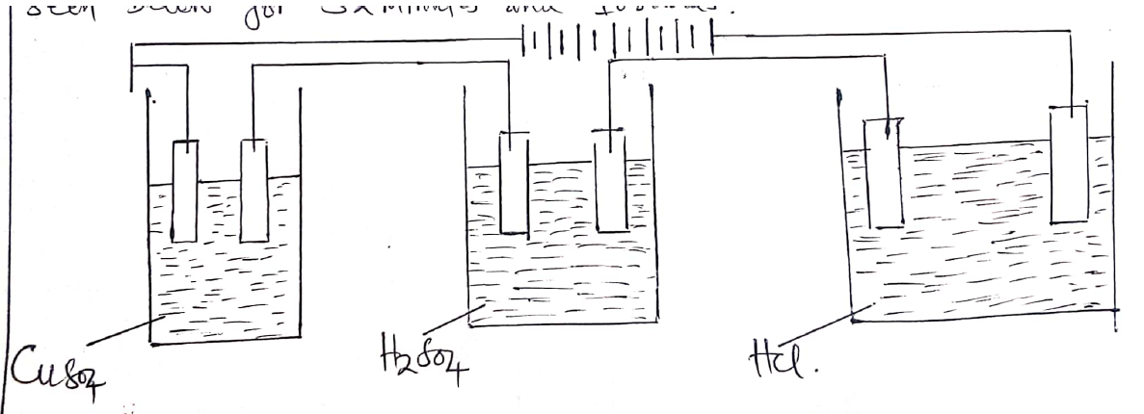

(i)Find the quantity of electricity passed in all voltmeters.

(ii)What mass of copper deposited in the first voltmeter?

(iii)What is the volume of oxygen gas liberated at the second voltmeter?

(iv)What is the moles of hydrogen gas liberated at the last voltmeter?

6.(a)Explain why covalent compounds do not conduct electricity compared with ionic compounds?

(b)Study carefully the electronic configurationof the elements given below then answer the questions that follow Q=2:7, R=2:8 and S=2:6

(i)What type of bond will exist in a compound formed when Q combines with R?

(ii)What group and period does element S occupy in a periodic table?

(iii)Write a molecular formula of a compound formed when element R combines with S?

(iv)What is a type of oxide formed when element R is burnt in air with oxygen gas?

7.The diagram below represents common methods of collecting gases in the laboratory.

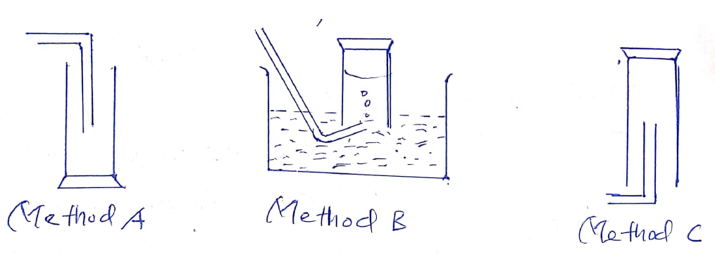

**P**

**N**

**M**

(a)Identify methods N and P.

(b)Which method is used in the laboratory gas preparation of

(i)Ammonia? (ii)Chlorine? (iii)Hydrogen? (Give a reason for your answers)

(c)What will happens if

(i)Yellow flowers are introduced into a gas jar containing chlorine gas?

(ii)A burnt splint is introduced into a gas jar containing hydrogen gas?

(iii)A glass rod is dipped in concentrated hydrochloric acid is introduced into a gas jar containing ammonia gas?

8.(a)Define any three types of organic reactions.

(b)Consider below compounds then answer the questions that follow

A = C2H4, B = C2H6O and C= C3H6O2

(i)In which homologous series does each compound belongs?

(ii)Write the IUPAC name of a compound formed when compound B combines with C.

(iii)Given a conversion C2H6O**X** C2H4**Y** C2H6.

What does each letter represents?

9.(a)Give the meaning of the following (i)Pollutants (ii)Macro-nutrients.

(b)(i)Explain why it is adviced to add acid in water and not water in acid?

(ii)Why soil productivity is necessary and not soil fertility?

(c)Briefly explain how you can test the presence of the following substances in air?

(i)Water (ii) Carbondioxide

10.(a)(i)What is solution?

(ii)Do you think a Coca Cola soda is a solution or suspension? (Give a reason for your answer).

(b)List down four(4) common stages in the extraction of less reactive metals.

(c)What is the molar concentration of

(i)Solution containing 10.4g of sodium carbonates in 200ml of the solution?

(ii)Solution containing 100g of sodium hydroxide in a litre of the solution?

11.(a)Given a diluted hydrochloric acid reacts with calcium carbonate to form different products. Write a blanced (i)Chemical equation for the reaction.

(ii)Ionic equation for the reaction.

(b)Mr Galan was conducting an experiment,accidentally he mixed solution of 40cm3 of 2M H2SO4 with the solution of 80cm3 of 0.4M H2SO4.Calculate the molarity of the resultant solution.

12.(a)A form four students tested solutions A, B, C, D and E with a universal indicator solution to find their PHvalues.The results of the experiments were as shown below

|  |  |
| --- | --- |
| Solutions | PH Values |
| A | 1 |
| B | 6 |
| C | 7 |
| D | 8 |
| E | 14 |

Which solution was (a) Strong acid? (b) Strong alkaline? (c) Weak acid? (d) Weak alkaline?

(b)(i)Why water is not used to put off oil fire?

(ii)Suppose your mother's clothes have caught fire.In order to extinguish fire,you have decided to cover with a damp blanket.What is the function of a damp blanket?

**SECTION C (15Marks).**

Answer only **one (1)** question in this section.

13.(a)(i)State the Avogadro's law of gaseous.

(ii)Find the amount of carbondioxide gas produced at standard temperature and pressure when 2litres of methane were burnt in air by oxygen gas.

(iii)Calculate the percentage composition of carbonate in Na2CO3.10H2O

(b)(i)Why hydrogen chloride gas is not collected over water during its preparation?

(ii)What is a test for hydrogen chloride gas? (Explain with aid of chemical equation).

(iii)What is the function of the concentrated sulphuric acid when preparing hydrochloride gas?

14.(a)Soil erosion is one of the problem facing many areas in Tabora region leading to poor harvests.As a chemist,outline four(4) advices to help peasants to overcome the soil erosion in Tabora region.

(b)The decomposition of an electrolytes by an electric current is called electrolysis.Define the ions that move to the (i) Cathode (ii) Anode

(c)Write a condensed formula and IUPAC name of any three positional isomers of a compound formed when pent-1-ene is hydrolysed by water.