**The Role of ICT in Business, Medicine Engineering, Data Management and Entertainment**

**Explain the Role of ICT in Business, Medicine Engineering, Data Management and Entertainment**

a)In Education:

* Students and teachers records processing and keeping as a computer aided learning (CAL) as well as computer aided instruction (CAI) used to access teaching and learning materials in the internet ( online learning
* Facilitate distance learning
* Can be used as a research tool e.g. to analyze data from experiment
* To assist education management.

b)In Industry and Engineering

* To design drawings for products using Computer Aided Design (CAD) programs
* To design drawing for products using computer aided design (CAD) programs example airplanes , bridges, buildings etc
* To manufacture products using computer aided manufacturing (CAM)
* To plan and control major projects
* To stimulate or predict what will happen in real life situations from a model situation example turning on/off traffic lights
* To control some operations in automobiles example mixing of fuel and air entering the engine
* A new technology called artificial intelligence can solve problems in areas like medicine ,law etc.
* To design drawings for products using Computer Aided Design (CAD) programs
* To design drawing for products using computer aided design (CAD) programs example airplanes , bridges, buildings etc
* To manufacture products using computer aided manufacturing (CAM)
* To plan and control major projects
* To stimulate or predict what will happen in real life situations from a model situation example turning on/off traffic lights
* To control some operations in automobiles example mixing of fuel and air entering the engine
* A new technology called artificial intelligence can solve problems in areas like medicine ,law etc.

c)In Banking and Business

* To allow bank clerks and customers to find out bank balance in an account
* To help bank clerks to record money paid in and out
* To check computer sensitive cheques , to do reservation system for airline travel by checking if there is free seat on a flight
* To help retailers to check out stock at a super market
* To allow people to use Automatic Teller Machine in cash withdrawal and transfer funds between accounts to keep track of current prices of market stocks , bonds and currency.
* Creates an effective way of producing document example reports, brochures, cards etc.

d)In Health

* In health computer can be used for Diagnosing illness.
* Modifying parent health development.
* Assisting surgeons.

e)Home

* Writing letter
* Listening music
* Playing game
* Watching movie

f)In Law Enforcement

* Storage information
* Making document and printing document
* DNA finger printing.

g) In Music Industry

* Composing music
* Editing sound
* Editing videos

h)In Transport

* It can be used for traffic control
* It can be used in driving stimulator
* It can be used for reservation systems
* Computers are embedded in air craft to provide efficiency in flying

i)In Government

* It can be used for internal revenue services i.e. to provide reports for tax purposes.
* It can be used for planning, analysis, forecast, sampling, predictions etc.
* It can be used for weather forecasting
* It can be used for law enforcement

j)In Military

* It can be used for planning and decision making
* It can be used by planners to stimulate wars
* It can be used to guide modern weapons such as missiles and field artillery

k)In Communication

* Communication has become cheaper quicker and more efficient.
* We can now communicate with anyone around the world buy text messages or email for an almost instantaneous response.
* The internet has also opened up face to face direct communication from different parts of the world thanks to the helps of video conferencing.
* Telephone switching transmission of computer data via network and electronic mail.
* Transportation connections, time table, scheduling times, road, airways, railways etc

**The Roles of ICT in Creating Awareness on Gender, HIV/AID, Drug and Drug abuse, Globalization, Family Life, Cultural changes, Corruption and Road Safety.**

**Explain the Roles of ICT in Creating Awareness on Gender, HIV/AID, Drug and Drug abuse, Globalization, Family Life, Cultural changes, Corruption and Road Safety.**

A) HIV/AIDS and ICT

The use of information and communications technologies (ICT) complements other Information Education and Communications (IEC) campaigns designed to reach youth. The same technology resources - e-mail, CD-ROMs, and the World Wide Web - that can link HIV/AIDS educators and activists around the world, also holds great promise for reaching youth, who typically embrace the use of the technology for entertainment, learning and communication when given access to these resources. Since early 2000, World Links and its project partners have been running the AIDS WEB project in secondary schools in Africa using information and communications technology (ICT) to promote HIV/AIDS education and prevention activities. Early results from the project suggest that technology can play a complementary and useful role in helping combat this horrible pandemic.

B) ICT AND ROAD SAFETY

ICT is an enabler of road safety. With real time data gathering and analysis, it can provide up to second information about traffic situation and also propose alternative routes. It can help better plan and manage the road safety for the individual commuter as well as the whole system. Developed countries are more and more relying on ICT for road safety, whereas the developing countries are following the suit at their own pace ICT can be used for real time monitoring of over speeding Vehicles on the roads using IP cameras.

C) ICT and GENDER

ICTs have been promoted by international organizations such as United Nations Educational, Scientific and Cultural Organization, the World Bank and the FAO as a poverty reduction strategy with the additional benefit of empowering women in developing countries. A study by the International Development Research Centre of Canada (IDRC) on ICT for poverty reduction strategies states that trends show that ICT have been applied to systemic improvements important to poverty reduction such as education, health and social services delivery, broader Government transparency and accountability, helping empower citizens and build social organization voice. However, existing persistent gender discrimination in labour markets, in education and training opportunities, and allocation of financial resources for entrepreneurship and business development, negatively impact women’s potential to fully utilize ICT for economic, social and political empowerment. Research and studies have highlighted the many benefits of ICT for women’s empowerment, through increasing their access to information on health, nutrition, and education. Projects founded by NGOs and international organizations include providing WAP phones to women in Senegal to help them check the price of food items and communicate with other women in the network, there by breaking down the digital divide.

**D) THE ROLE OF ICT IN CREATING AWARENESS ON CORRUPTION**

In recent years, many governments have worked to increase openness and transparency in their actions. Information and communication technologies (ICTs) are seen by many as a cost-effective and convenient means to promote openness and transparency and to reduce corruption. E-government, in particular, has been used in many prominent, comprehensive transparency efforts in a number of nations. While some of these individual efforts have received considerable attention, the issue of whether these ICT-enabled efforts have the potential to create a substantive social change in attitudes toward transparency has not been widely considered.

**E) THE ROLE OF ICT TO SPREAD INFORMATION**

Information about Gender, HIV/AIDS, drug/ drug abuse and corruption is dispread and received all over the world through communication media such as TV, Radio, CD-ROMs, newspapers and computer internet etc.

**F) ICT AND GENDER SENSITIVITY**

Girls and boys have equal right to join the school woman have a right to own land

**G) ICT AND GLOBALIZATION**

ICT has not only brought the world closer together, but it has allowed the world’s economy to become a single interdependent system. This means that we can not only share information quickly and efficiently, but we can also bring down barriers of linguistic and geographic boundaries. The world has developed into a global village due to the help of information and communication technology allowing countries like Chile and Japan who are not only separated by distance but also by language to share ideas and information with each other.

**H) ICT AND CULTURAL CHANGES**

Bridging the cultural gap (interactivity) - Information and communication technology has helped to bridge the cultural gap by helping people from different cultures to communicate with one another and allow for the exchange of views and ideas thus increasing awareness and reducing prejudice. With ICT local radios can be much more interactive and run more economically than a decade ago

**ICT and Crimes**

**The Criminal Activities Facilitated by ICT**

**Explain Criminal Activities Facilitated by ICT**

Some ICT criminal cases include the following:

1. Viruses Transmission
2. Junk mail
3. Unauthorized electronic money transfer. Virus, worms, and Trojan
4. Undesired contents,
5. Denial of contents organized crimes

**Junk mail** is an unwanted or unsolicited advertising or promotional material received through the post or sent as email.

**Organized crime** is a category of transnational, national, or local groupings of highly centralized enterprises run by criminals who intend to engage in illegal activity, most commonly for money and profit. Some criminal organizations, such as terrorist groups, are politically motivated. Sometimes criminal organizations force people to do business with them, such as when a gang extorts money from shopkeepers for so-called protection

**DENIAL OF SERVICE (DoS)** is a type of attack on a network that is designed to bring the network to its knees by flooding it with useless traffic. Many DoS attacks, such as the

*Ping of Death* and *Teardrop* attacks, exploit limitations in the TCP/IP protocols. For all known DoS attacks, there are software fixes that system administrators can install to limit the damage caused by the attacks. But, like viruses, new DoS attacks are constantly being dreamed up by hackers.

**ICT and Employment**

**The Effects of ICT on Employment**

**The Dedate on the Effects of ICT on Employment**

ICT employment is defined as the people working in the Information and Communication Technology (ICT) sector. This indicator is measured as a percentage of business sector employment.

* Greater connectivity, more than 120 countries now have over 80 percent market penetration of mobile telephones
* Digitization of more aspects of work ,today telecommuting and outsourcing have become standard business practices globally
* More globalized skills, India and the Philippines have become major outsourcing hubs thanks to their English language skills, and other countries are targeting the sector for future growth.

ICTs are providing new avenues for job creation that could help tackle global unemployment. For instance, the development of the mobile phone applications industry has created new opportunities for small- and medium-sized enterprises (SMEs). A firm that provides a digital application to the Apple app store, for example, gains access to over 500 million app store account holders.

ICTs connect people to jobs. Online employment marketplaces are helping an estimated 12 million people worldwide find work by connecting them with employers globally. Babajob in India, Duma and M-Kazi in Kenya, and Souktel in the Middle East and North Africa are examples of job search services using internet-based and mobile tools. Such services empower workers by making labor markets more transparent and inclusive; for instance, Souktel targets low-income and marginalized communities.

ICTs also support innovation that has created new, more flexible forms of employment and work:

* Online contracting uses ICT to increase access to work opportunities worldwide, mainly for smaller employers. Popular services include oDesk and Elance. In 2012, about 2.5 million jobs were posted on these services, for tasks ranging from writing to customer service to software development.
* Microwork platforms break down large business processes into smaller discrete tasks – such as data entry and verification, copy-writing, or graphic design – and distribute them to workers across geographic boundaries. The platforms include Cloud Factory, Mobile Works, and Sam source. Analysts suggest the market size is about US$1 billion today and could grow to about US$5 billion by 2018.

ICTs create opportunities, but also pose new challenges for workers and employers. By enabling new forms of work, ICT also changes the structure of jobs, the way people develop their career, and the way they work. Many ICT-enabled jobs are temporary or contract-based, for example, leading to a separation of work from social safety nets such as health insurance or pensions. But, for young people especially, they offer a way into more formal careers, as well as providing a supplementary income.

ICT Hazards

The Effect of Disposing Electronic Equipments to the Environment

Explain the Effects of Disposing Electronic Equipments to the Environment

**1. Air**

**How does e-waste contaminate air?**

Air can be contaminated by e-waste primarily when e-waste is transported to countries where recycling processes are poorly regulated, as is typical in informal economies. In these informal economies, e-waste is often dismantled and shredded, releasing dust or large particulates into the immediate environment where the respiratory health of workers without proper respiratory protection is hurt, often seriously and chronically. E-waste of little value is often burned and low value e-waste tends to contain a great deal of plastic. Unregulated or under-regulated burning is often carried out at lower temperatures and releases toxins, such as dioxins, which are potent and damaging to human and animal health in a myriad of ways. Burning also releases fine particles which can travel hundreds if not thousands of miles and bring about negative consequences to respiratory health and bypass the body’s defense mechanisms, increasing the risk for a wide range of chronic diseases and cancers. Finally, higher value materials, such as gold and silver, are often extracted from highly integrated electronics and e-waste using acids, desoldering, and other chemicals and techniques which release additional damaging fumes into local communities when recycling is not properly regulated. The impacts of informal recycling of e-waste on air are worst for the workers who handle this waste, but can extend, tens, hundreds, and sometimes thousands of miles away from recycling sites.

How are ecosystems impacted?

Some animal species are more profoundly impacted by air pollution than others, which in addition to endangering these species, also endangers the biodiversity of regions that are chronically and heavily polluted. Over the long term, air pollution can hurt water quality, soil chemistry, and plant species, creating damaging and irreversible changes in ecosystems. For example, lead levels in air near informal recycling hubs like Guiyu, China can be up to three times those found in industrial European sites. Lead can be inhaled while still in the air and ingested when it returns to water and soil. Once ingested or inhaled, it can bio-accumulate up the food chain, causing disproportionate neurological damage to larger animals and wildlife, including human beings.

**How are human beings impacted?**

Human beings can inhale fine (small) particles generated from informal recycling practices and toxic chemicals from these same practices. Fine particles are of particular concern because (a) they can travel long distances through air from their point of origin, thus impacting communities far away from where the pollution was generated; and (b) they bypass the body’s respiratory defense mechanisms and can cause a wide range of health problems, chronic, acute, and otherwise. Short term exposure to fine particles is often linked with eye irritation, asthma attacks, and acute bronchitis while long term exposure can result in reduced lung function, chronic bronchitis, lung cancer, and a wide range of systemic problems that extend well behind compromised respiratory health. These risks are especially heightened for older adults who already have heart or lung issues such as asthma or coronary heart disease. Being exposed to particle pollution can aggravate these diseases and even lead to death. For children, inhaling particles can not only result in immediate respiratory difficulty but can also increase the risk of debilitating respiratory disease later in life.

Soil

**how does e-waste contaminate soil?**

Soil can be contaminated in two primary ways from e-waste: (a) through direct contact with contaminants from e-waste or the byproducts of e-waste recycling and disposal; or (b) indirectly through irrigation from contaminated water.

When e-waste is improperly disposed in regular landfills or illegally dumped, both heavy metals (lead, arsenic, cadmium, and others) and flame retardants in e-waste can leach directly from the e-waste into the soil, causing contamination of underlying groundwater or contaminating crops that may be planted in that soil now or in the future.

When e-waste is not recycled properly as is the case in areas of the world where recycling practices for e-waste are not regulated or are informally monitored, soil can become directly contaminated by (a) effluent or waste products from leaching practices which extract precious metals and other valuable materials from e-waste; (b) coarse particles and bottom ash generated from dismantling, shredding, or burning of e-waste; and (c) leaching of heavy metals not recovered during recycling into underlying soil during disposal. Practices used to extract precious metals from e-waste such as mercury amalgamation or cyanide leaching can release additional toxic substances to the soil. Dismantling can also release large, coarse particles into the air, which due to their size and weight, quickly re-deposit to the ground and subsequently contaminate soil.

**How does ecosystems impacted through e-waste soil?**

Fundamentally, heavy metals (from improper e-waste disposal and incomplete recycling activities), PBDEs (from burning , shredding, and dismantling), dioxins/furans (from incomplete burning) and acidification from recycling practices which involve leaching change the composition of soil in unpredictable and complex ways. These changes can be very harmful to micro-organisms in the soil and plants, as well as animals and wildlife that rely on these plants for survival. Plants often suffer from damaged cell structure, altered metabolism, and reduced growth in contaminated soils. In addition, some plant species can be doubly impacted by e-waste through the contamination of underlying soil and through direct contact with contaminants. Lead, for example, can coat the surface of leaves, reducing the rate of photosynthesis within a plant and causing damage or death.

Exposure to contaminated plants/vegetation can create compounding exposures to heavy metals (e.g. lead, arsenic, cadmium), dioxins, furans, PBDEs and other potent pollutants. Animals are not only inhaling contaminated air but also consuming plants contaminated by underlying soil. Since many of these pollutants bio-accumulate up the food chain, the larger the animal, the more the impact, which can cause complex and disturbing disruptions to biodiversity and ecosystem balance in contaminated areas.

How does e-waste impact human beings on the soil?

Humans are doubly impacted by contaminated soil via consuming crops grown in contaminated soil and eating eggs, meat, and fish where toxic substances have bio-accumulated (increased in concentration) up the food chain. For children, these effects are further compounded because children are more likely to play in contaminated soil and ingest contaminated soil through poor hygiene or inadequate hand-washing practices.

**Water**

**How does e-waste contaminate water?**

Water can be contaminated by e-waste in two major ways: (a) via landfills that are not properly designed to contain e-waste; and (b) via improper recycling and subsequent disposal of e-waste. Electronic components often contain precious metals and other desirable materials that make e-waste lucrative for many to recycle and reuse these materials, particularly certain impoverished communities in developing countries. Extracting materials from highly integrated systems, as many electronics are in modern design, is complicated and can require shredding, burning, leaching, and other processing that produces toxic byproducts in air, water, and soil.

Surface water, in particular, is affected by the chemical processes used to extract precious metals like gold from electronic devices. These processes typically leach or strip precious materials away from less valuable materials like plastic using acids and other toxic chemicals that, when improperly treated or regulated, are released into local water sources such as streams, ponds, and rivers. Through these pathways, acidification and toxification of water can extend to communities miles away from a recycling site, impacting public and ecosystem health in many, many ways. Ground water can also be impacted by improper disposal or dumping of e-waste as heavy metals (like lead, arsenic, and cadmium) and other persistent chemicals leach from landfills and illegal dump sites into ground water tables, affecting people and animal life for many miles around.

How does ecosystems impacted through water?

One of the biggest impacts to ecosystems through water sources contaminated by e-waste is through acidification of surface waterways. Acids used to extract and leach precious metals from e-waste during recycling and reuse enter into local waters when improperly handled.

Heavy metals can also enter surface waters through improper recycling and handling of e-waste. For example, in fish, ingestion of mercury readily leads to neurological damage, permanent disabilities and damage to the immune system. Heavy metals can also lead to tissue and gill damage as well as erratic movements among many species of fish. These heavy metal impacts extend well beyond fish, above and beneath these fish on the food chain, ultimately extending to human beings and public health.

How are human beings impacted through e-waste in the water?

When surface waters are contaminated by the products of e-waste, those drinking from, bathing, and recreating in these waters are impacted. Many toxic chemicals can impact surface waters but heavy metals can impact both surface and ground waters.

**The Health Hazards of ICT use to Human Life**

**Outline the Health Hazards of ICT use to Human Life**

**1. Eye-Strain**

One health issue that can occur after using computers for a long time is **eye-strain** (tiredness of the eyes). This is caused by looking at a **monitor** which is a **constant distance** away. The muscles that focus your eyes do not move, and so get **tired** and **painful**. Eye-strain can also cause **headaches**.

This problem can be solved

* **Look away** from the monitor at **regular intervals** – re-focus on distant or close objects to exercise the muscles in the eye.
* **Take regular breaks**.
* Use an **anti-glare filter** in front of the monitor to cut down on screen reflections that can also tire the eyes.

**2. Back and Neck Ache**

Many people suffer from **back and neck pain** after working at a computer for a long time. This is usually due to them having a **bad sitting posture**.

This problem can be solved:

* Use an **adjustable, ergonomic chair**, and take the time to s**et it up properly**.
* The computer **keyboard** and **monitor** should be at the **correct height** for the seated person (keyboard lower than the elbow, top of monitor at eye level).
* **Take regular breaks**: get up, walk around, stretch your muscles

**3. Repetitive Strain Injury (RSI) in Wrists and Hands**

Any **repetitive** movement (same movement over and over again) can result in a health problem called **repetitive strain injury** (RSI).

In particular, **typing** and using a **mouse** for long periods are common causes of **RSI** in the **wrist** (it is often called carpal-tunnel syndrome).

This problem can be solved,

* Use a **wrist-rest** to support the wrists while typing and when using the mouse.
* **Take regular breaks** from typing or using the mouse.

**WEB DEVELOPMENT**

**The Concepts of a Webpage**

**Explain Concepts of a webpage**

**A web page** is a document commonly written in Hypertext Markup Language (HTML) that is accessible through the Internet or other network using an Internet browser. A web page is accessed by entering a URL address and may contain text, graphics and hyperlinks to other web pages and files. The page you are reading now is an example of a web page.

**Website** a set of related web pages located under a single domain name. or this is is a collection of related web pages, including multimedia content, typically identified with a common domain name, and published on at least one web server

A connected group of pages on the World Wide Web regarded as a single entity, usually maintained by one person or organization and devoted to a single topic or several closely related topics.

The software used to create website are:

* Text editors e.g. Notepad and WordPad etc.
* Macromedia Dreamweaver
* HTML Kit
* Microsoft Home page
* Microsoft FrontPage etc.

If you want to master this topic, you should be able to use the following terms correctly in your assignments and exams:

* **HTML**: Stand for Hypertext Markup Language, a simple scripting language to create a webpage
* **Hypertext:** Simply a piece of text that works as a link
* **Markup Language**: is a way of writing information within documents
* **Tag:** is a markup for telling the browser.Make sure you know who your audience is. For example customers, Employees, Students, Friends, Family
* If you making a site for your company, make sure the goal is specific and quantitative.
* **Keep your goal simple**. A couple of sentences or a short paragraph is enough. If your goal is too long, your site will end up looking like it’s trying to do too much.
* **Script** : A list of commands that can be executed without user interaction
* **Script language**: A simple programming language which you can write scripts
* **Perl:** Script programming language that is similar in syntax to C language
* **APS:** Server side scripting language that can be included inside HTML file.

The Webpage Structure

Prepare a Webpage Structure

Web “sites” are complete abstractions—they don’t exist, except in our heads. When we identify a site as such, what we’re really describing is a collection of individual linked pages that share a common graphic and navigational look and feel. What creates the illusion of continuity across a cohesive “site” is the design features that pages share. Individual html pages and how they are designed and linked are the atomic unit of web sites, and everything that characterizes site structure must appear in the page templates.

As the web has matured over the past decade, the structure of web pages in text-driven information sites has become more uniform and predictable. Although not all web pages share the exact layout and features described here, most web pages incorporate some or all of these basic components, in page locations that have become familiar to web users

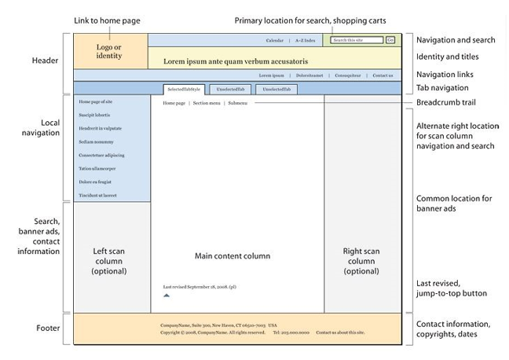

Header

* Usually a big strip across the top with a big heading and/or logo. This is where the main common information about a website usually stays from one web page to another.

Navigation bar

* Links to the site's main sections; usually represented by menu buttons, links, or tabs. Like the header, this content usually remains consistent from one webpage to another — having an inconsistent navigation on your website will just lead to confused, frustrated users. Many web designers consider the navigation bar to be part of the header rather than an individual component, but that's not a requirement; in fact some also argue that having the two separate is better for accessibility, as screen readers can read the two features better if they are separate.

Main content

* A big area in the center that contains most of the unique content of a given webpage, for example the video you want to watch, or the main story you're reading, or the map you want to view, or the news headlines, etc. This is the one part of the website that definitely will vary from page to page!

**Sidebar**

* Some peripheral info, links, quotes, ads, etc. Usually this is contextual to what is contained in the main content (for example on a news article page, the sidebar might contain the author's bio, or links to related articles) but there are also cases where you'll find some recurring elements like a secondary navigation system.

**Footer**

* A strip across the bottom of the page that generally contains fine print, copyright notices, or contact info. It's a place to put common information (like the header) but usually that information is not critical or secondary to the website itself. The footer is also sometimes used for SEO purposes, by providing links for quick access to popular content.

Create a Webpage

Create a Webpage

Write HTML Using Notepad or TextEdit

Web pages can be created and modified by using professional HTML editors. However, for learning HTML we recommend a simple text editor like Notepad (PC) or TextEdit (Mac).

We believe using a simple text editor is a good way to learn HTML. Follow the four steps below to create your first web page with Notepad or TextEdit.

1.Open Notepad (PC)

* **Windows 8 or later:** Open the Start Screen (the window symbol at the bottom left on your screen). Type Notepad.
* **Windows 7 or earlier:** Open Start > Programs > Accessories > Notepad Open TextEdit
* **Mac:** Open Finder > Applications > TextEditor Also change some preferences to get the application to save files correctly.In Preferences > Format > choose "Plain Text"Then under "Open and Save", check the box that says "Ignore rich text commands in HTML files".Then open a new document to place the code.

2.Write Some HTML

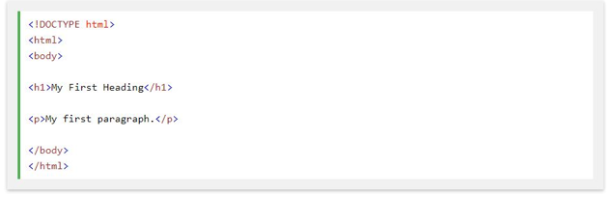

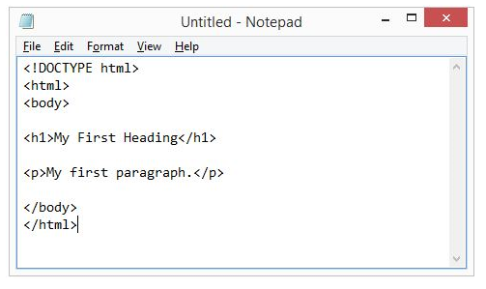

3. Save the HTML Page

* Save the file on your computer. Select File > Save as in the Notepad menu.Name the file "index.htm" and set the encoding to UTF-8 (which is the preferred encoding for HTML files).

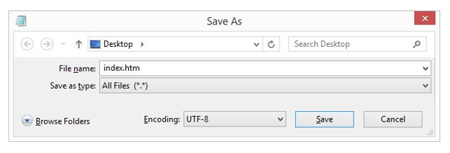

* You can use either .html or .html as file extension. There is no difference, it is up to you.

4.View the HTML Page in Your Browser

* Open the saved HTML file in your favorite browser (double click on the file, or right-click - and choose "Open with").
* The result will look much like this:

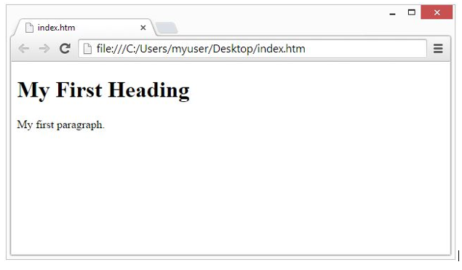

HTML Documents

* All HTML documents must start with a document type declaration: <!DOCTYPE html>.
* The HTML document itself begins with <html> and ends with </html>.
* The visible part of the HTML document is between <body> and </body>.

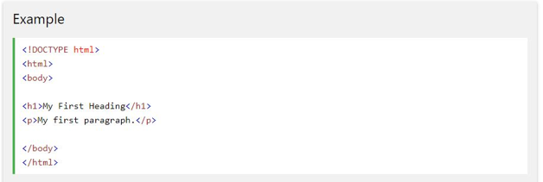

HTML Headings

* HTML headings are defined with the <h1> to <h6> tags.
* <h1> defines the most important heading. <h6> defines the least important heading:

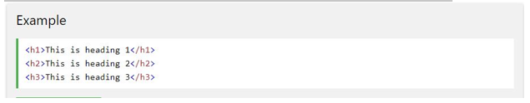

HTML Paragraphs

* HTML paragraphs are defined with the <p> tag:

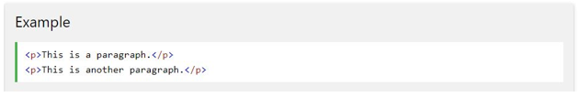

HTML Links

* HTML links are defined with the <a> tag:

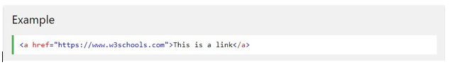

* The link's destination is specified in the href attribute. Attributes are used to provide additional information about HTML elements.

HTML Images

* HTML images are defined with the <img> tag.
* The source file (src), alternative text (alt), width, and height are provided as attributes:

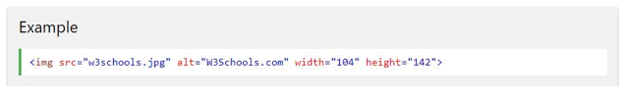

HTML Elements

* An HTML element usually consists of a start tag and end tag, with the content inserted in between:<tagname>Content goes here...</tagname>
* The HTML element is everything from the start tag to the end tag:<p>My first paragraph.</p>

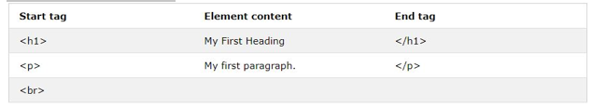

* HTML elements with no content are called empty elements. Empty elements do not have an end tag, such as the <br> element (which indicates a line break).

Nested HTML Elements

* HTML elements can be nested (elements can contain elements).
* All HTML documents consist of nested HTML elements.
* This example contains four HTML elements:

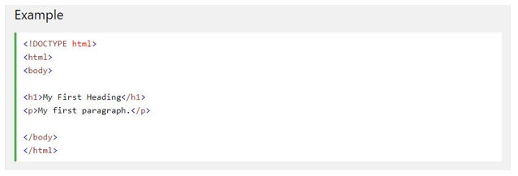

Example Explained

* The <html> element defines the whole document.
* It has a start tag <html> and an end tag </html>.
* The element content is another HTML element (the <body> element).

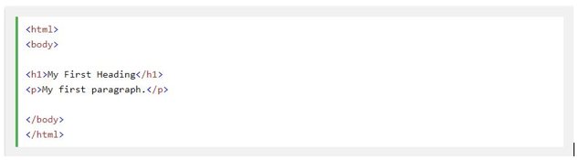

* The <body> element defines the document body.
* It has a start tag <body> and an end tag </body>.
* The element content is two other HTML elements (<h1> and <p>).

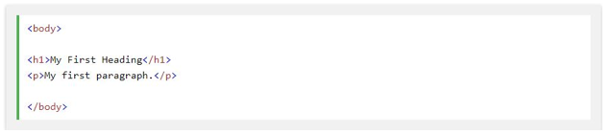

* The <h1> element defines a heading.
* It has a start tag <h1> and an end tag </h1>.The element content is: My First Heading.

https://sdimg.blob.core.windows.net/images/ShuleDirect/52945/Original/Capture9_1523765893954.png

The Webpage Preview

Explain Webpage Preview

The preview view shows an approximate view of what the page would look like in a Web browser. Things like dashed lines for tables won’t appear in the view

**The Concepts of Publishing Webpage**

**Explain a Concepts of Publishing Webpage**

Once you finish writing the code and organizing the files that make up your website, you need to put it all online so people can find it. **Publishing Webpages** is the process of copying all the files to a remote location on a server.

The Importance of Publishing Webpage

Outline the Importance of Publishing Webpages

The webpages become available to other people either in World Wide Web (internet) or in local Area (internet). This will enable targeted audience to access information from website. People may download the pages they need, plus all of its associated files like forms, pictures and so on.

The Procedure of transferring Webpages to the webserver

Explain the Procedure of transferring Webpages to the webserver

**PROCEDURE OF TRANSFERRING WEBPAGE TO THE WEB SERVER**

* Web server is a computer that runs special serving software. That software “serves” HTML pages and associated files when requested by a client, such as Web browser.
* When you use your browser to visit a site, you typically make your request by entering a URL (for example: http://example.microsoft.com). A URL is a uniform Resource Locator. It’s simply an address for a file on the web.
* When the server receives your request, it serves or downloads the page you need, plus all of its associated files like pictures and so on.

**WEB SERVER DETAILS**

* The URL for your site may be determined by your hosting company, but you can also register your own unique URL.
* The correct file name for your home page: home pages can be named index.html, default.html, or default.html depending on the kind of server your site will reside on.
* User name and password: these are often needed to publish pages to a remote server.
* Server restrictions: the total file size of your site’s files may not be able to exceed a certain size or other restrictions to use certain

THE DIFFERENCE BETWEEN WEBPAGE AND WEBSITE

|  |  |
| --- | --- |
| WEBSITE | WEBPAGE |
| **A website** is a collection of webpages that are under 1 domain (such as mywebsite.com). Forexample if there is a company that owns abccompany.com then this website will have several Webpages like Home, About Us, Contact Us, Testimonials, Products, Services, FAQ’s, and others. All of these pages together make up a Website. | **A webpage** is an independent page of a Website. For example a webpage would bethe testimonials page. A web page can be accessed by typically one URL in a browser and that page can be copied and or send to a friend for review whereas websites are collections of multiple page that must be navigated to view other content. |

* The web page is a smaller part of a larger website usually containing more specific information. If a website were a book, then a webpage would be a chapter in that book. Whether you cite a site or a page for a paper or project depends on what information you used.

Access information on a website

Access information on a website

**Information access** is the freedom or ability to identify, obtain and make use of data or information effectively. For most people nowadays, using the internet involves accessing information or entertainment, viewing products and services, or using social media platforms to keep in touch with friends and acquaintances.

* The easiest way to access a website is to write the desired address into the address bar located in the browser. This address is known as a Uniform Resource Locator (URL), and every webpage can be reached with its own individual URL (web address). A URL is made up of several sections; all of which have their own functions. Here is a generic example of a webpage URL:

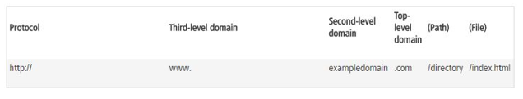

**DATABASE**

Manual data Processing System

Describe Manual data processing system

**Manual data processing system** refers as traditional way of data processing. These data are made up by computer. They are pencil and paper data processing. It’s a physical organization of raw data to turn into usable form of information. This usually can be applicable when data is collected through paper questionnaire, or postcards.

Electronic Data Processing Systems

The Electron Data Progressing System

Describe the Electronic Data Progressing System

**Electronic data processing system** refers as modern way of data processing. These data are made up by computer. They are ease to format, edit, remove or add the content

The Comparison of Manual and Electronic Data Processing Systems

Compare Manual and Electronic Data Processing Systems

DIFFERENCE BETWEEN MANUAL AND ELECTRONIC DATA PROCESSING

|  |  |
| --- | --- |
| Manual data processing system | Electronic data processing system |
| Low technology data processing e.g paper and pencil | Very high technology data processing e.g computer |
| Difficult to adjust | Easy to adjust i.e formatting,editing |
| Difficult to produce copies with the same quality | Easy to produce more copies with the same quality |
| It takes time to produce data required | It takes a very short time to produce data required(depends on user's operating speed) |
| Difficult to move to different location | Can move to different locations easily |
| Cannot be printed | Information can be printed |
| Generally not easy to read | Generally easy to read |

The Importance of data Processing

Explain the Importance of Data Processing

Importance of data processing

* To have records to be use on future
* To be up-to- date
* Secure
* Plan for the future

Database Concepts and Terminologies

The Database Terminologies

Explain Database Terminologies

Database concept and terminologies

* **Criteria**– the conditions that control which records to display in a query.
* **Database**– a collection of information related to a particular topic or purpose. There are two types of databases: i)Non-relational and ii)Relational.
* **Database management system**– a program such as Access, that stores, retrieves, arranges, and formats information contained in a database.
* **Database model**– the structure of the information stored in the database. This model should included how each individual piece of information relates to all the other information in the database. Proper planning, even in the initial pencil-and-paper stage, ensures that the database you create and maintain is efficient and provides easy access to the information you need most. A well-designed database should eliminate the need to enter the same data repeatedly and prevent duplication of information, thereby maintaining the integrity of the data.
* **Database modeling** – the process of strategically planning where to store each piece of information you wish to include in your database.
* **Datashee**t – a format of columns and rows displaying information.
* **Display formats (format)** - Specifies how data is displayed and printed. An Access database provides standard formats for specific data types, as does an Access project for the equivalent SQL data types. You can also create custom formats.
* **Field** – a specific item of information containing a homogeneous set of values throughout the table. Fields appear as columns in a table and as cells in a form.
* **Field data types**- a characteristic of a field that determines what kind of data it can store. For example, a field whose data type is Text can store data consisting of either text or number characters, but a Number field can store only numerical data.
* **Field list** – a small window that lists the fields of a selected table or data source.
* **Form** – a structured document with specific areas for viewing or entering data one record at a time. Forms can be constructed in columnar, tabular, datasheet, or a simple justified format.
* **Join line** – the line between two tables identifying the common field between them.
* **Non-relational database**– also called a flat file, stores information in one table. Non-relational databases are useful for information stored in a single list, such as a list of student names, addresses, and phone numbers.
* **Object**– a component of a database, such as a table, query, form, or report.
* **One-to-many relationship** – a relationship in which a record in the primary table can be related to one or more records in the related table.
* **One-to-one relationship** – a relationship between two tables in which for each record in the first table, there is only one corresponding record in the related table.
* **Primary Key** – a field in a table whose value is uniquely identifies each record in the table.
* **Query**– a request for a particular collection of data in a database.
* **Query By Example (QBE) grid**– the portion of the Query Design window used for selecting fields, setting criteria, and setting sort order in a select query.

|  |  |
| --- | --- |
| ROW | DESCRIPTION |
| Field | Displays the name of the field used in the query |
| Table | Displays the name of the table from which a field is selected. |
| Sort | Determines the order in which to display the records in the record set. |
| Show | Determines whether the field used appears in the record set. |
| Criteria | Displays selective criteria used to filter the query. |
| Or | Displays additional criteria for the query. |

* **Record**– an individual listing of related information consisting of a number of related fields stored in a table. A record is also called a row in the datasheet.
* **Record set** – the set of records and fields that result from running a query.
* **Related table**– a table with a common field that uses values stored in a primary table.
* **Relational database**– is useful for maintaining and analyzing complex information stored in a number of tables. For example, in addition to storing student names, you can list TAKS test scores, or demographic information related to the students in other tables in the same database.
* **Relationship**– the direct or indirect association between any two tables in a database.
* **Report** – a formatted collection of information organized to provide printed data on a specific subject.
* **Select Query** – a query that answers a question about one or more tables by limiting the number of records and fields displayed.
* **Table** – an arrangement of related information stored in columns and rows.

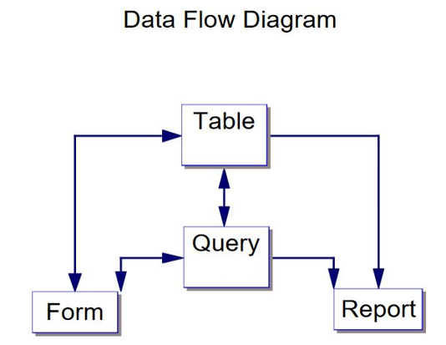

Type of Database Systems

The Importance of Database Systems

Explain the Importance of Database Systems

IMPORTANCE OF DATABASE SYSTEM

* **Sharing:** in organizations, information from one department can be ready shared with others
* **Security:** users are given passwords or access only to the kind of information they need to know e.g. payroll department may have access to employee’s pay rates, but other department would not.
* **Fewer files:** with several departments having access to one file, there are fewer files.
* **Data integrity:** order filing systems many times did not have “integrity” that is a change made in a file in one department might not be made in the file in another department

The Types of Database System

List Types of Database Systems

There are four (4) kinds’ databases

1. **Individual**: is also called microcomputer database. It is a collection of integrated file primarily used by just one person
2. **Company**: May be stored on a mainframe computer and managed by a computer professional (database administrator) users throughout the company have access to the database through their microcomputers linked to local area networks or wide area networks. There are two types of company database 1. Common operational database 2. Common user database
3. **Distributed**: it is located in a place(s) other than where users are located. Typically database savers on a client/server network provide a link between users and distant data .E.g. information can be at regional offices. Some can be at headquarters, some down the hall from and some even overseas
4. **Propriety**: is generally an enormous database that an organization develops to cover certain particular subject. It offers access to this database to the public or selected outside individuals for fee.
5. Creating Database
6. Plan for a Database
7. Plan for a Database
8. A Table for Data Entry
9. Prepare a Table for Data Entry
10. Data Entry form
11. Prepare a Data Entry form
12. Enter Data Using forms and Tables
13. Enter Data Using forms and Tables
14. The help Facility Database
15. Use the help Facility Database