* **ST.MARIE EUGENIE GIRLS SECONDARY SCHOOL**
* **HOLIDAY PACKAGE FORM TWO - 2020**
* **BASIC MATHEMATICS**

**CODE: 041**

**TIME: 21/2 HOURS March, 2020**

* This paper consists of ten (10) compulsory questions
* Attempt all questions and show all the working clearly
* Mathematical tables may be used
* Write your examination number/name one every page of your answer sheet

1. a) Simplify 14 - $\left[-2-\left(8 ÷2\right)+ 5\right]$

b) Arrange the following numbers in descending order

2/3, 6/12, 3/2, 0.35 and 60%

1. a) (i) Increase 320,000 by 16%

(ii) Convert 1/7 in decimal correct to three decimal place

b) (i) Change 256800cm into km

(ii) Write 260743 correct to three significant figures

1. 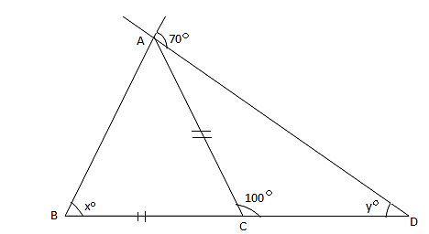a) Find the value of x and y in the figure below

b) The exterior angle of a regular polygon is 36 $°$ find.

i) The number of sides of the polygon

ii) The sum of the interior angle of the polygon

iii) Give the name of the polygon

1. a) If $P*Q$ = 3P – Q (i) Evaluate (5 $*3) *2$ (ii) Find m if m

b) If X2 + 8x + q = (x + k)2. Find the value of k and q

1. a) Simplify (i) $\frac{\log{x^{4}-\log{x}}}{\log{x^{3}-\log{x}}}$ (ii) 27¼ x 3¼ x ${\left(\sqrt{3}\right)}^{-2}$

b) Simplify $\frac{2\sqrt{3}+ 4}{\sqrt{3}- \sqrt{2}}$ by rationalizing the denominator

1. a) Solve $y^{2}$– $\frac{4}{3}$ y – 5 = 0 by completing the square.

b) A straight line passes through two points A(-3,6) and B(-6,3). Find the equation of the line AB

1. 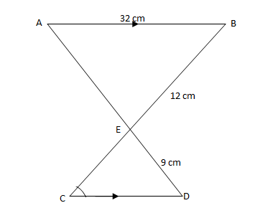a) Two triangles below are similar. Calculate the length of $\overline{CD}$

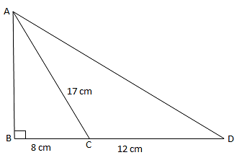b) From the figure below find the length AD

1. Find the image of a point (1,4) after reflection in the line
2. y-axis
3. x-axis
4. y = x

b) Make ‘a’ the subject of the formula if $\frac{x}{y}$ = $\frac{a+1}{b-1}$

1. a) (i) Factorize 3x2 + 7x – 6 by splitting the middle term

(ii) Factorize a2 – b2 and use it to find the exact value of (10003)2 – (9997)2

b) Solve $\left\{\begin{aligned}y=20-2x \\ -35= -3y-x\end{aligned}\right.$ by elimination method

1. a) Use mathematical tables to evaluate $\frac{\sqrt{21.3} × {(1.93)}^{2}}{0.014 × 4756}$

b) A motorcycle is bought for 1,200,000/= and sold at a profit of 12% find.

(i) Profit made

(ii) Selling price

**THE END**